Market Trends for Home Smart Devices

iRobot
Prepared by: Seth Ricks
Date: 8/15/2025

Report Overview
As technology continues to advance, the home robotics industry is experiencing steady growth. Consumers want devices and robots that make their lives simpler and free up more time. Despite this, there are trends that put certain home robots over others, such as seemingly ‘smarter’ devices that can confirm their commands. There are also challenges that consumers encounter which make them hesitate to buy these products, such as high prices or a lack of trust in home security. Both trends and challenges will be presented and analyzed in the following report.

Growth in the Market
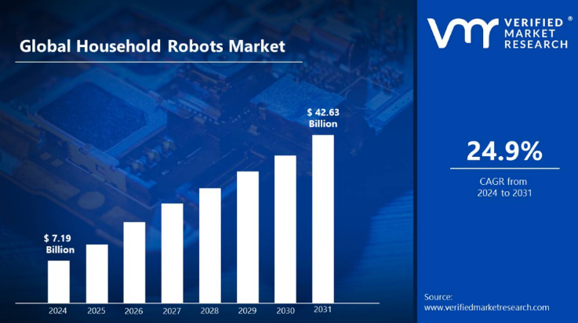
There is noticeable growth in the household robotics market. According to Figure 1, produced by Verified Market Research (2025), the household robotics market is estimated to grow by a CAGR (Compound Annual Growth Rate) of 24.9% globally. If these projections hold, this industry will grow more than sixfold in just seven years. With the current market valued around 7.19 billion, it is projected to reach 42.63 billion by 2031.
Figure 1
As shown by Mintel (2024), 69% of consumers have devices that can connect to Wi-Fi. Similarly, 45% have devices that connect to Bluetooth, and 28% have smart technology designed to make their home run more smoothly. These trends show that not only are home devices becoming more popular, but they are also almost considered necessary.

Trends
While it is obvious that this market has potential, there are certain trends in the industry that can cause products to flourish, and others to fail. These are largely influenced by user preferences, and by how the lifestyle of an average person is continuing to grow more complicated.
In an age where time and simplicity are valuable commodities, consumers continue to want devices that simplify their lives and give them more free time. According to Mintel (2025), most want robots to “simplify life without adding complexity” (para. 3). Current trends show that most consumers have or are interested in the home devices that are the smartest and most capable. These include TVs, speakers, security systems, lights, and appliances (Mintel, 2025). All of these have feedback, either visual or audible. The devices that are the least popular are smart blinds, smart water control, and smart vacuums (Mintel, 2025). Consumers pick these home robots for varying reasons, but the most popular are home security, comfort, and freeing up time (Mintel, 2024).
According to Mintel (2024), the aspects that most consumers value most when purchasing home robots include being able to control them with a device (smartphone or remote control), controlling them when they are not home, and voice control. About 55% of consumers say that the robots they purchase can be controlled with another device. This trend shows that not only do consumers want robots that are efficient and reliable, but they also want them to be easily controlled. This is likely connected to the insecurity many people have about potential malfunctions, or the risk of being hacked and misused. For example, if someone can control their smart security system when they are not home, they may feel more secure than if I could not. Generally, people like to have control over their devices and systems, to ensure issues can be easily stopped or reversed if necessary.

Challenges
Despite the growing market and the obvious influx of consumers wanting to invest their money in the home robotics market, there are many challenges that arise. Some of these include products being too expensive for the tasks they perform, limited and sometimes flawed functionality and performance, and some users who distrust robots with running their homes.
One of the biggest issues that consumers face is performance and installation challenges. According to Mintel (2024), 23% of those surveyed thought that smart home devices are too complicated to install. Verified Market Research (2025) states, “Despite progress, many robots still struggle with complex tasks and difficult environments … Vacuum robots frequently struggle to navigate cluttered spaces, clean corners, and handle thick carpets. Mopping robots may also struggle to remove sticky stains efficiently. These constraints make them less useful than standard cleaning procedures” (para. 6). This is only one of many issues that can occur with a home robot. Many consumers may know that robots can be tipped over, broken, or even make a mess.
There is an obvious issue of pricing. The issue with being on the forefront of technology is that many of these advanced devices are expensive. According to Martel (2025), “44% of US consumers believe these devices are too expensive, making consumers uncertain whether the benefits outweigh the initial investment” (para. 3). This implies that consumers want more advanced devices, and they’d likely be more willing to pay for them if they had larger benefits. For what robots can currently perform, many don’t think the purchase is worth the cost.
Finally, the greatest barrier that many consumers face when deciding whether to buy a home device is trust concerns. Namely, the smarter a device is and the more control it has, the more potential it has to be hacked, or malfunction. 41% of consumers think that this is a root cause for avoiding a smart home device, as shown by Mintel (2024).

Conclusion
The household robotics market is complicated and divided. Consumers want technology that performs better and is more reliable. At the same time, they don’t want this technology to be expensive or ‘hackable’. In short, this industry has a lot of potential, but many challenges. If companies in this area wish to be on top of consumers’ lists, they need to make products that are smarter, cheaper, and more reliable.

References
Mintel. (2025, April 23). Smarter robot companions. Mintel.
https://reports.mintel.com/trends/#/observation/1217405
Mintel. (2024). Tech trends: Connected home & hardware – US. Mintel.
https://data mintel.com/databook/tech-trends-connected-home-hardware-us-2024/
Verified Market Research. (2025, February). Household Robots Market. Verified Market
Research. https://www.verifiedmarketresearch.com/product/household-robots-market/

